Technically Speaking 8-7-14

Faculty friends,

SSW Canvas Work Sessions at 811 Washington (new added)
There are 2 more previously scheduled brown bag work session times in 321 if you have Canvas questions and/or want to come and work on building your courses in Canvas with me and your colleagues:
- Monday , August 4th, from noon-1pm.
- Wednesday, August 13th, noon-1pm.
And I have added 4 new sessions before classes begin in room 115:
- Thursday, August 14th, from 3:30-4:30pm.
- Monday, August 18th, from 3:00-4:00pm.
- Wednesday, August 20th, from noon-1:00pm.
- Friday, August 22nd, from 9:00-11:00am.

Canvas Faculty Resource Guides
The Baylor Electronic Library has put together this Canvas resource page:
https://baylor.instructure.com/courses/366
Also the Canvas Help Telephone Hotline has been working rather well and is available 24/7 for technical assistance: 844-334-0228

Stretching the Canvas (Canvas Tips of the Week)
1. It’s a good idea to hide items from students on the left menu of your Canvas course that you won’t be using.
To do this, go to Settings on the left menu (bottom), then click on the Navigation tab in the middle of the window at the top, and then drag items from the top box to the bottom to hide them.
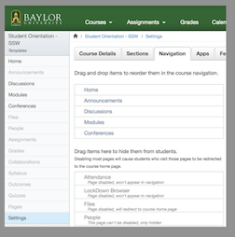
2. It’s always a good idea to back-up your courses:
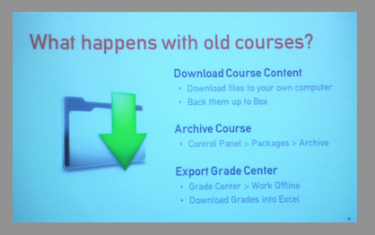

Classroom Technology Help
As always, please contact me if you are having classroom technical issues (my cell 254-855-4171).
If you cannot reach me, there are now cards on the podiums with a Baylor Classroom Technology assistance phone number.

Today’s Bitstrip
So this one isn’t funny and is a bit on the arrogant side, but please feel free to contact me in regard to assisting with course design…
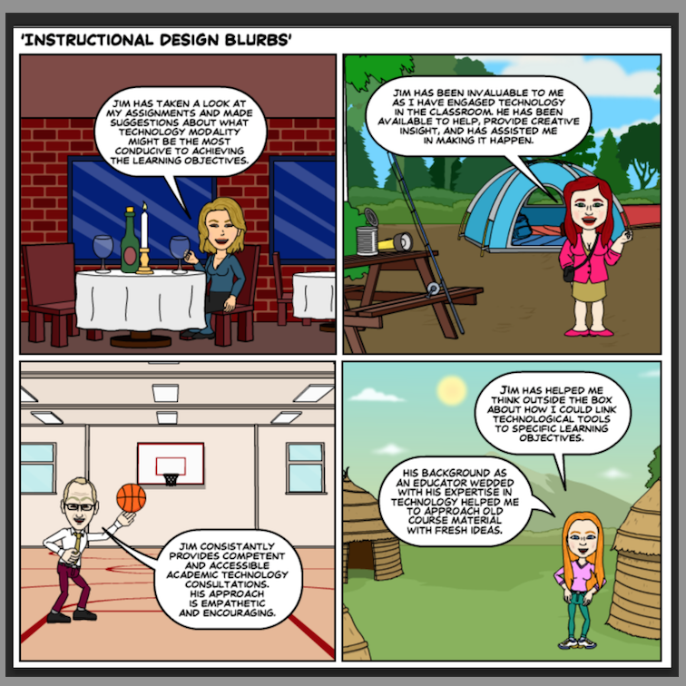

Until next week,

Jim Heston
Coordinator of Academic Technology
Baylor School of Social Work
One Bear Place #97320
Waco, TX 76798-7320
(254) 710-6419

