Technically Speaking 8-21-14

Faculty friends,

SSW Canvas Work Sessions at 811 Washington
Fall classes beginMonday, and I have 2 more work session times in 321 if you have Canvas questions and/or want to come and work on building your courses in Canvas with me and your colleagues:
- Friday, August 22nd, from 9:00-11:00am and 2:00-4:00pm.
Also, don’t forget about the Canvas Help Telephone Hotline available 24/7 for technical assistance: 844-334-0228

Stretching the Canvas
Canvas apps are available for iPhone and iPad as well as Android phones and tablets.
Speedgrader is also available on the iPad.
http://www.baylor.edu/canvas/index.php?id=865084
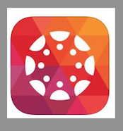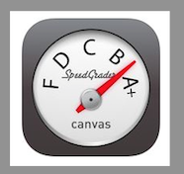

Baylor Website
Both Box and Canvas have been added to the list of online tools on the the Faculty & Staff section of the Baylor website (http://www.baylor.edu/facultystaff).
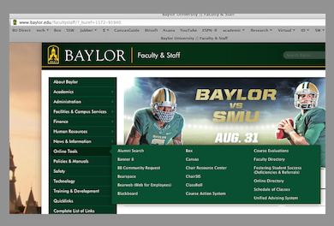

Virtually Speaking
Janet Sheets (Janet_Sheets@baylor.edu, 254-710-2335), our library liaison, informed us that she has a new resource for video streaming called Kanopy.
She says that all of the resources from Pychotherapy.net are available and that you can search for Kanopy in the library’s list of databases or in BearCat (http://bearcat.baylor.edu).

Today’s Bitstrip
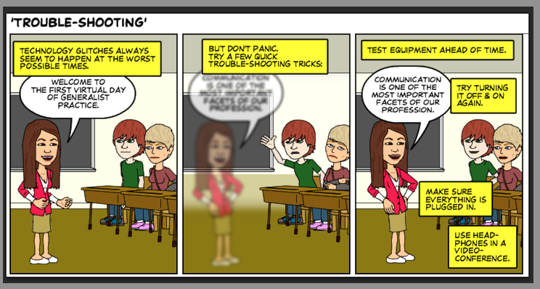

Until next week,

Jim Heston
Coordinator of Academic Technology
Baylor School of Social Work
One Bear Place #97320
Waco, TX 76798-7320
(254) 710-6419

