Technically Speaking 7-31-14

Faculty friends,

SSW Canvas Work Sessions at 811 Washington
I will continue to host informal brown bag work session times in 321 (come-and-go) to be available if you want to come and work on building your courses in Canvas with me and your colleagues:
- Monday , August 4th, from noon-1pm.
- Wednesday, August 13th, noon-1pm.

Stretching the Canvas (Canvas Tip of the Week)
When it comes time to publish your Canvas course so that students can see it, there is a green Publish button on the top right of the course Home page.
However, there is also a second step that is a little tricky if there are multiple sections of the class — see the attached document.
Also, once a course is published, you can decide which pages and modules are visible to students — they are not automatically published when the course is. To check this, look under Modules and see if the cloud icons next to the Module and the content underneath are gray (unpublished) or green with a check mark (published); click on the cloud to change it.
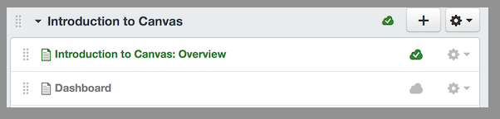

Virtually Speaking (Online Tip of the Week)
Often instructors show videos for various reasons, and showing these in a traditional class is as simple as projecting a DVD or YouTube clip.
Doing the same thing in a virtual environment becomes trickier for several reasons such as:
- copyright law is not the same,
- video-conferencing bandwidth often prohibits showing an additional video,
- managing synchronous/asynchronous viewing schedules,
- uploading a dvd to others online.
If this is something that you may need for your course, please set up a time to meet with me to discuss possibilities.
We have found that if you can find a video already online, that you can post the link in Canvas; if you want to watch as a part of a synchronous class, you can have students watch it on their own immediately before class or take an extended break somewhere in the middle of class.
Jim Ellor had a request to show a Joseph Campbell DVD to his online PhD students around the world, and we were able to work with the Baylor library to look into copyright, digitize it, and then make it available online for 24 hours to the students, but each situation may vary in how this process works.
My contact for this in the library is Beth Farwell who says to plan ahead as much as possible, hopefully 4-6 weeks if the situation such as Jim’s needs to occur. She also says:
Our preference is to be able to provide more purchased streaming, so we aren’t bumping into digital rights management / fair use / copyright issues.
Have you looked at any of the videos offered through our databases?
In particular Alexander Street Press has some interesting collections that we’ve already purchased:
- Counseling and Therapy in video online — http://ezproxy.baylor.edu/login?url=http://ctiv.alexanderstreet.com/
- Academic Video online (you can browse some of these by discipline) — http://ezproxy.baylor.edu/login?url=http://video.alexanderstreet.com

Today’s Bitstrip
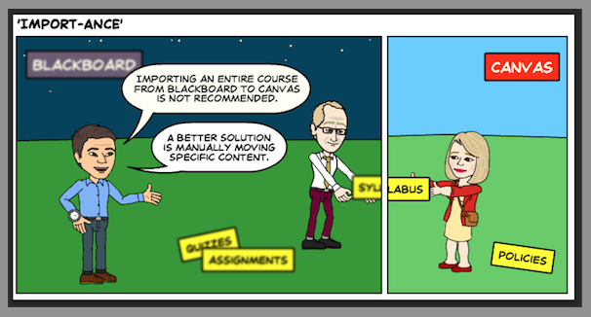

Until next week,

Jim Heston
Coordinator of Academic Technology
Baylor School of Social Work
One Bear Place #97320
Waco, TX 76798-7320
(254) 710-6419

