Technically Speaking 6-4-14

Faculty friends,

Transition to Canvas
Baylor is transitioning from BlackBoard LMS to Canvas. While BlackBoard will be available until summer 2015, we are recommending the use of Canvas as soon as possible, especially for MSW and PhD courses.
We recommend taking one or both of the 2 on-campus courses below (info and registration https://www1.baylor.edu/td_reg/BrowseAll.aspx):
Canvas Intro
- 6/5 1:30-2:30
- 6/10 10:00-11:00
- 6/19 1:30-2:30
- 6/24 10:00-11:00
- 7/3 1:30-2:30
- 8/7 1:00-2:00
- 8/14 1:30-2:30
Canvas Core
- 7/10 9:30-3:30
- 7/15 9:30-3:30
- 7/24 9:30-3:30
- 8/6 9:30-3:30
- 8/12 9:30-3:30
- 8/12 9:30-3:30
We have requested to host a Canvas Course Make-over session at 811 Washington tailored for social work sometime in July.
You can find out more about Canvas and/or register for demo course account (http://www.baylor.edu/lib/factech/index.php?id=863026) and watch video tutorials/guides of Canvas (http://guides.instructure.com/m/4210).

New Tools in the Building
- Room 115 now has a cork rail on the wall that holds 4 removable 2-sided whiteboard slates that can be used for such things as group brainstorming assignments that can then be posted for the class to see.
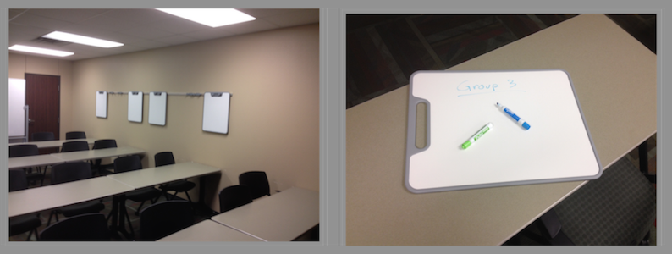
- Practice lab 108 (inside the computer lab) now has an iMac for staff/faculty/student use. It can not only be used for those preferring a Mac or in need of Mac applications, but it also has a built-in video camera and iMovie video-editing software so that recording, editing, and saving/sharing (YouTube, Box, flashdrive) can all be accomplished in the same room.
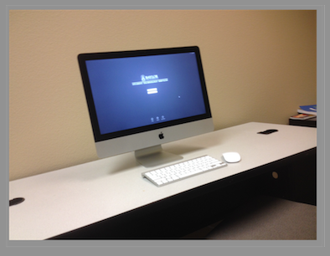

Today’s Bitstrip
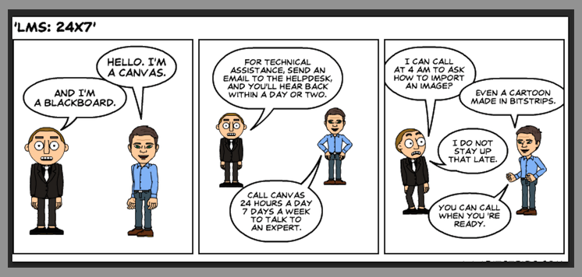

Until next week,

Jim Heston
Coordinator of Academic Technology
Baylor School of Social Work
One Bear Place #97320
Waco, TX 76798-7320
(254) 710-6419

