Technically Speaking 5-7-14

Faculty friends,

Trainings
- May 19-21 Course Make-over Workshop by the Academy of Teaching & Learning

Living Room Sound System
If there is a need to use the sound system in the Living Room, feel free to contact me for assistance in planning set-up. I have created an instructional sheet for its use and have attached it to this email and posted it inside the closet in the Living Room 250.01 near the system cabinet.

Mac Adapters in Classrooms
Now that Colloquium is over, I’ve installed Mac adapters in all of classroom and also the DCR and 330.
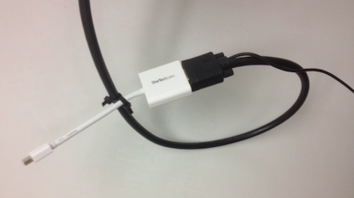

In the News
CampusTechnology.com had a recent article on a Baylor study “Can FaceBook Make Better Students”: http://campustechnology.com/articles/2014/05/01/can-facebook-make-better-students.aspx
Slate.com had a recent article titled “Can Flipped Classrooms Help Students Learn?”: http://www.slate.com/articles/technology/future_tense/2014/04/flipped_classrooms_can_they_help_students_learn.html

Best Practices in Online Technology
Below are 10 best practice for online learning that I adapted from a rubric created by QualityMatters.com:
1. The course is backward-designed/goal-centered and easily works as modules.
2. Instructions and purpose are clearly stated.
3. Norms and policies are agreed upon and posted.
4. Prerequisite discipline/course and technology skills/expectations are clear.
5. Learning objectives are clear, measurable, and course-appropriate.
6. Varied assessments measure course objectives and inform students of their own progress.
7. Specific criteria for assignments are tied to a clearly stated grading policy.
8. Modes of interaction (synchronous and asynchronous) fit specific course objectives.
9. Activities and instructional materials (including texts, media, and technology) contribute to course objectives, respond to varied learning styles, and are up-to-date.

10. Technology is selected based on best fitting course objectives, accessible, and has technical support instructions.

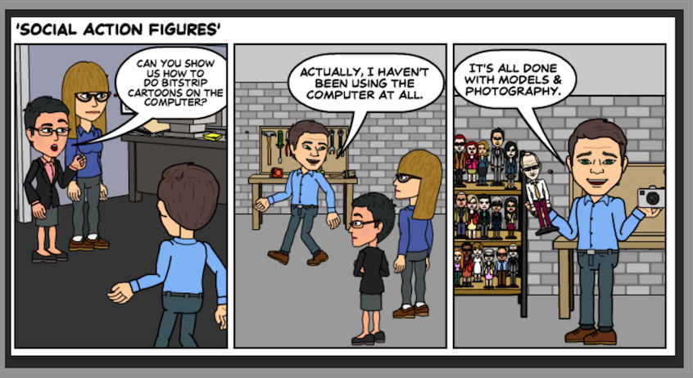

Until next week,

Jim Heston
Coordinator of Academic Technology
Baylor School of Social Work
One Bear Place #97320
Waco, TX 76798-7320
(254) 710-6419

