Technically Speaking 5-23-14

Faculty friends,

Contacting Me
When I joined the BU SSW last July, I gave out my email address (jimdheston@gmail.com) because I didn’t have an @baylor.edu.
A few people still are using that address to contact me (probably typing in my name, and that is the first address that pops up).
I do want you to know that I check that address but only maybe once a day. For a quicker response, please use my Baylor email (jim_heston@baylor.edu). For an even more immediate response, feel free to call or text my cell phone (254-855-4171).

Starting a Presentation
The image below is an anonymous internet meme called “Advice Mallard.”
I have attached an example of a PowerPoint saved as a .pps file.

Summer Travel Tech Safety
Many of you are traveling more over the summer. Below are a few links to safety tips. I especially like the idea in the top Baylor link that suggests that you treat your laptop like cash, never leaving it unattended.
- http://www.baylor.edu/content/services/document.php/125193.pdf
- http://www.wanderingearl.com/traveling-with-technology-how-i-keep-it-safe/
- http://businesstravel.about.com/od/travelgadgets/a/Technology-Travel-Tips.htm#.

Online Teaching Article
Campus Technology has an interesting article called “6 Ways To Be a Better Online Teacher”: http://campustechnology.realviewdigital.com/?
The 6 Ways are:
- Maximize Your Digital Savvy
- Be an Active and Engaged Participant
- Reinvent Your Wheel
- Include Your Learners in the Learning Process
- Reassess Assessment
- Realize It’s Okay to Fail

Updates
- I am now archiving these “Technically Speaking” newsletters on my website: http://tech4social.weebly.com/technically-speaking-archive.html
- 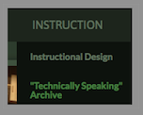
- HaikuDeck (free online presentation software) offers some new features such as image editing: http://us2.campaign-archive1.com/?u=adfa3190f365a81690030bbe1&id=7fa05229eb&e=55796552ab

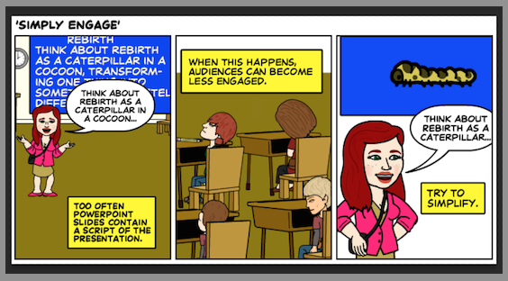

Until next week,

Jim Heston
Coordinator of Academic Technology
Baylor School of Social Work
One Bear Place #97320
Waco, TX 76798-7320
(254) 710-6419

