Technically Speaking 4-30-14

Faculty friends,

Trainings
- May 19-21 Course Make-over Workshop by the Academy of Teaching & Learning
Dr. Anne Schultz, Director of the BIC, will lead this, and I will be attending myself.
Helen says, “Several of us did this workshop last year…I found it very beneficial and a good use of my time and I recommend it to you."

Mac Adapters in Classrooms
You may have noticed that there are now Mac VGA/thunder projector adapters (AKA dongles) that are attached to the VGA cables in some of our classrooms (currently, 115, 120, 135, 320, and 321).
I have ordered more, and — after students use those during Colloquium next Tuesday — I’ll install them in all of classroom and also the DCR and 330.
The picture below shows how they can be looped around and used.
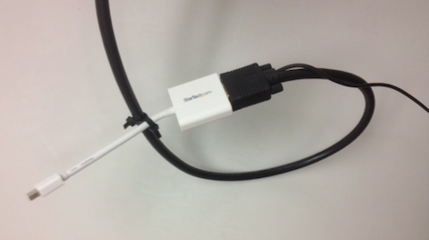

Voicethread
Voicethread (https://voicethread.com) is on online tool to post video and documents and allows voice, text, or video responses.
See a demo here: https://www.youtube.com/watch?v=yW2nb7FO7p8.
The free version allows you to create 5 threads (up to 50 slides each); however, you cannot delete the threads.
You can manually delete all of the internal content of the thread creating a blank slate to start a new thread as a work-around.
The paid versions allows unlimited threads and integration into an LMS but are rather costly.

Embedding Hyperlinks & Video into Presentations
If you or your students are interested in embedding websites links or including video into presentations (Haiku Deck, PowerPoint, or Prezi), I have attached a chart with procedures for each.

Internet Explorer Alert from Baylor ITS
Last Saturday, Microsoft acknowledged an exploit in all versions of its Internet Explorer browser that may allow hackers to run malicious code on your Windows-based device. Microsoft is developing a fix, but in the mean time, Baylor ITS recommends that you switch to an alternate browser:
Google Chrome: www.google.com/intl/en/chrome/browser/
Mozilla Firefox: www.mozilla.org/en-US/firefox/new/
In addition, you should update your Adobe Flash Player to the latest version by visiting: http://get.adobe.com/flashplayer.
Certain administrative applications used by the university require Internet Explorer. This exploit does not impact these specific uses of Internet Explorer, so you may continue to use Internet Explorer to access these systems.If you have questions, please contact the HELP Desk at (254) 710-HELP.

Corrections & Updates
1. Jennifer Dickey and I have found that sometimes Haiku Deck (https://www.haikudeck.com) freezes up when trying to delete or search for images.
If this is happening try looking at the URL: if it is it https:// then delet the s.
2. If you have trouble getting on http://bitstrips.com (the website that allows me to create the cartoons like the one below) on your laptop, try using http://bitstrips.com/pageone/ instead.

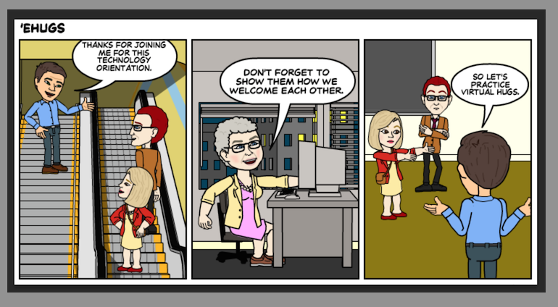

Until next week,

Jim Heston
Coordinator of Academic Technology
Baylor School of Social Work
One Bear Place #97320
Waco, TX 76798-7320
(254) 710-6419

