Technically Speaking 4-2-14

Faculty friends,

Trainings This Week
- 04/1-3/14 ELI Focus Session & Transformational Teaching Showcase, Jones 200, 11-2:30, baylor.edu/library/eli
- 04/02/14 Ethics: The Power of One

PowerPoint & Alternatives
Sometimes students (and even occasionally instructors) need advice on their PowerPoints; here are some tips: http://www.makeuseof.com/tag/10-tips-for-preparing-a-professional-presentation/ .
Also, some of you may have already started using the online presentation software Prezi: http://prezi.com.
Here's a 1 minute "Prezi Tutorial: Getting Started" video: https://www.youtube.com/watch?v=ddpiS983SUE.
Here's an example of one of my Prezis: http://prezi.com/8vvexh5cg5gx/?utm_campaign=share&utm_medium=copy&rc=ex0share
There is also Haiku Deck (https://www.haikudeck.com) which is an online image-centric presentation software that easily finds creative commons (legal) images and embeds documentation of them. Here's an example slide:
And here is a 4 minute video tutorial: https://www.youtube.com/watch?v=8vnUFNXK4qs

Video Recording
With the prevalence of cell phones with cameras, it would seem that it would be easy to capture and share video at the drop of a hat. But there are a few barriers in the way:
- Sharing a 10 second video of your cat dancing is much easier than sharing an hour long recording of a class because of the size difference of those files.
  - The recording device has to have the memory capacity for the video.
  - Time often needs to be committed to editing large video files.
  - Uploading/saving takes almost as long as the length of the recording.
  - A distribution method needs to be implemented.
- Different devices record and play in different formats that aren't always compatible. For best compatability, I recommend:
  - Recording in MP4 format.
  - Playing using VLC: http://www.videolan.org/vlc/download-windows.html
- The security/privacy-level must be balanced against the ease of accessibility.
Please feel free to contact me if you have questions. For more information, see the attached "Creating and Sharing Video" document or see http://tech4social.weebly.com, go to the HOW TO tab and go to Use Video on the drop-down menu.
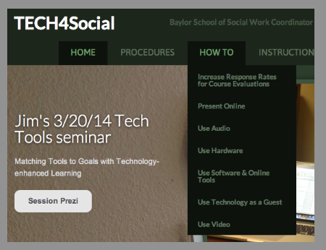

Until next week,

Jim Heston
Coordinator of Academic Technology
Baylor School of Social Work
One Bear Place #97320
Waco, TX 76798-7320
(254) 710-6419

