Technically Speaking 4-17-14

Faculty friends,

Room 321 Podium Computer System
Since the only “smart" podium in the building is one in room 321, there seems to be some continuing frustration related to its use. For this computer/projector/screen, please only use the touchpad on the podium both to turn it on and off (I recommend using the Start Rooms Separately option).
Turning on/off the projector with a remote or lowering/raising the screen using the wall switch usually results in confusing the system causing audio to become lost.
I have locked the 321 projector remote in the podium and labelled the 320 remote to not be used in 321.
Soon I will produce a tutorial video and may model the use during an upcoming faculty/staculty meeting.

Software Available
If you were unaware, Baylor lists available software for faculty, staff, and students in the software directory http://www.baylor.edu/its/index.php?id=44648.
There is also an easy installer site https://www7.baylor.edu/appcenter/bin/core.asp?path=appcenter&cat=home.

Instructional Design
Please remember that I am available to work with you individually or in small groups to assist in helping refresh or redesign instructional content for not only virtual classes but also traditional or hybrid classes.
I also have few books such as Supporting Students for Success in Online Distance Education (http://www.amazon.com/Supporting-Students-Success-Distance-Education/dp/0415509106/ref=tmm_pap_title_0?ie=UTF8&qid=1397770003&sr=8-1) and e-Learning and Social Networking Handbook: Resources for Higher Education (http://www.amazon.com/Learning-Social-Networking-Handbook-Resources/dp/0415503752/ref=tmm_pap_title_0?ie=UTF8&qid=1397770099&sr=1-1) for checkout.
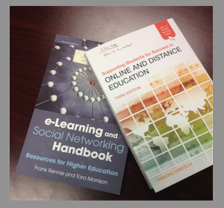

Avatars
After including a cartoon in this newsletter last week, Becky emailed me that she wished she had a job that included making cartoons.
I responded that she could use them to introduce modules on BlackBoard and quickly sent her a single cartoon panel of herself and posted some content from her syllabus in the word balloon.
I use http://bitstrips.com (no drawing skills needed). There are quite a few ideas floating around about how to use avatars in the classroom (and virtual classroom) including this one: http://www.guide2digitallearning.com/teaching_learning/10_ways_use_avatars_education.
Angela Pool-Funai and I have been talking about a way to demonstrate Second Life (http://secondlife.com) as an instructional tool.
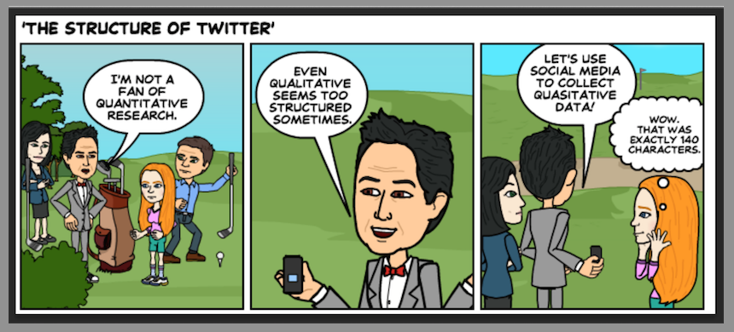

Until next week,

Jim Heston
Coordinator of Academic Technology
Baylor School of Social Work
One Bear Place #97320
Waco, TX 76798-7320
(254) 710-6419

