Technically Speaking 10-31-14

Faculty friends,

The TED 10 Commandments
There’s both a Prezi and a more informative list of the TED 10 Commandments for public speaking at http://blog.prezi.com/latest/2014/9/3/what-does-it-really-take-to-reach-the-speaking-worlds-bigges.html?utm_source=whatsnewoct&utm_medium=email&utm_campaign=blog
In summary, they are:
- Thou shalt be the real you.
- Thou shalt play to thy greatest strengths.
- Thou shalt connect with thy audience.
- Thou shalt write thy words with a copywriter’s pen.
- Thou shalt speak simple, compelling truths.
- Thou shalt begin and end in greatness.
- Thou shalt harken to thy voice.
- Thou shalt delight thy audience.
- Thou shalt worship beautiful images.
- Thou shalt practice out loud.

Online Course Design
Here’s an article on what not to do in online course design (with explanations of what to do as well):
http://onlinelearninginsights.wordpress.com/2012/08/06/how-not-to-design-an-online-course/
- What not to do: Use the same face-to-face course syllabus: Professor Harding has a detailed syllabus he has perfected over years of teaching his face-to-face class and with a few minor modifications, he plans to use this syllabus for the online course.
- 2. What not to do: Implement Course grading that relies heavily on exam assessments. Harding’s face-to-face course is heavily test based with 70% of course grade allocated to exams and tests, 25% to assignments and 5% to participation. Given the significant test and exam weight, Harding plans to mandate that students complete all exams and tests in a proctored setting to ensure academic integrity.
- What not to do: Assignments that lack detailed instructions: There are two assignments for this History course with descriptions of each in the course syllabus. Assignment details are outlined in two paragraphs within the syllabus, though professor Harding usually gives his face-to-face students enhanced instructions during his classroom lectures.
- What not to do: Utilize the same course materials as used in F2F class. The course materials for the history class consist of a textbook, several handouts, and power point slides, all of which (except for textbook) the professor plans to post to the course home page.
- What not to do: Underestimate the amount of time needed for course transition. This is one of the most common mistakes of all, underestimating how much time is needed to bring a course to the online format.
And here’s another interesting article on virtual classes: http://blog.capterra.com/challenges-of-using-video-conferencing-in-online-courses/

Learning Styles Revisited
Here’s a an article that speaks back to the learning styles debate: http://www.educatorstechnology.com/2013/12/the-myth-of-learning-styles-debunked.html
And an info graphic…
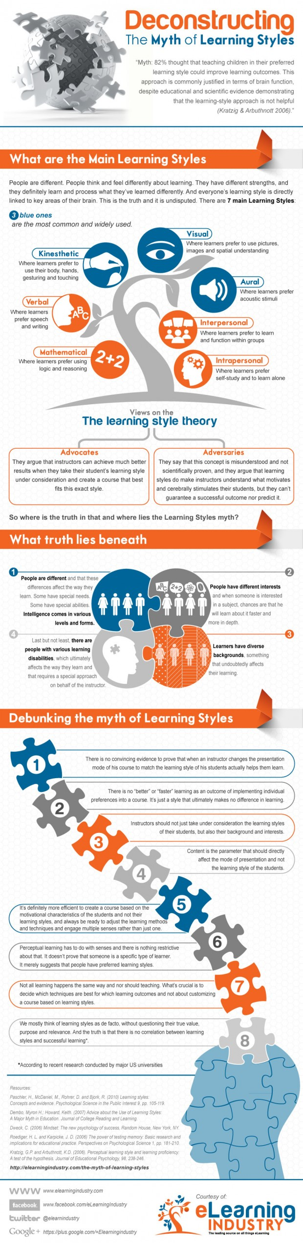

Today’s BitStrip
The cartoon link is not clickable so you can use this: http://bit.ly/BU2-factor
I’ll be speaking more about 2-factor authentication at Tuesday’s staculty meeting.
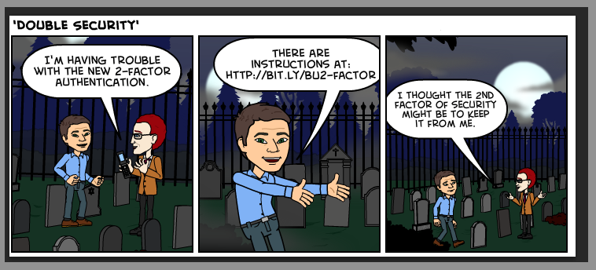

Until next week,

Jim Heston
Coordinator of Academic Technology
Baylor School of Social Work
One Bear Place #97320
Waco, TX 76798-7320
(254) 710-6419

