Technically Speaking 10-16-14

Faculty friends,

VLC Video Player
When trying to play videos of various sorts, especially those created by students, I suggest using VLC.
You can download it for Mac or PC for free: http://www.videolan.org/vlc/index.html

2 Factor Password Authentication
Starting with VPN, Baylor ITS security will be implementing the use of 2 factor security: password plus a push notification via cell phone.
On October 21, 2014, Baylor Information Technology Services will implement two-factor authentication on our VPN. After this date, in order to connect to the Baylor network using VPN, you will be required to provide your Bear ID, your passcode, and a code that will be provided to you through a text or voice message.
To prepare for this transition on Baylor’s VPN service, please take a moment now to enroll for Baylor2Factor at www.baylor.edu/2factor<http://www.baylor.edu/2factor>.
We are confident that you will appreciate the additional security Baylor2Factor will bring to the Baylor network. For more information, see the Baylor2Factor page at: www.baylor.edu/its/2factor<http://www.baylor.edu/its/2factor>. If you have any questions or experience issues during the Baylor2Factor enrollment process, please contact (254) 710-4357 (HELP).
In the near future, other Baylor systems that need added security may require this as well.
When you click on the first link above to enroll, it should take you less then 5 minutes.

Conferencing Issues
As a non-example for video-conferencing etiquette:
http://youtu.be/DYu_bGbZiiQ

Kanopy Video Streaming Update
Ramona McKeown sent this to me because she said that all of the Kanopy trial requests for campus have come from faculty in Social Work:
We had 391 visits to our Kanopy site in September. 43 films were played, 685 minutes. We now have licensed 4 films; one was from a purchase request; one was a free film they gave us; and two have actually been purchased because of the PDA plan, meaning they have been viewed at least 4 times.
Two new collections have been added to our Kanopy collection this week:
Sympton Media: Symptom Media is an online mental health education and training film library. These innovative DSM 5 and ICD guided films offer visual guideposts to better understand what a particular mental health diagnosis looks like. Ranging from 30 seconds to 15 minutes, the films are currently integrated into undergraduate, graduate and professional courses as instructors use as: visual anchors for reference, lecture & discussion; help students identify, understand and recognize nonverbal cues & body language indicators; provide points of reference for cross comparisons & differentiate between diagnoses; learn assessment skills; and integrate in exams for competency testing.
The producer said they had six trial requests from our faculty. I believe the trial requests came from Becky Scott, Carrie Arroyo, Cynthia Harr, Elizabeth Timmons, Helen Harris and James Ellor.
California Newsreel: California Newsreel produces cutting edge, social justice films that inspire, educate and engage audiences. Founded in 1968, Newsreel is the oldest non-profit, social issue documentary film center in the country, the first to marry media production and contemporary social movements. They are a leading resource center for the advancement of racial justice and diversity, and the study of African American life and history as well as African culture and politics.
A film from this collection was recommended by Eileen Bentsen.
REMINDER: Visit Baylor’s Kanopy collection at Error! Hyperlink reference not valid.

Today’s BitStrip
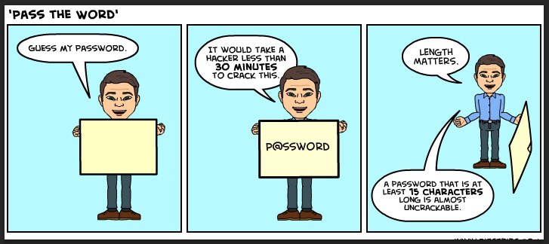

Today’s 2nd BitStrip
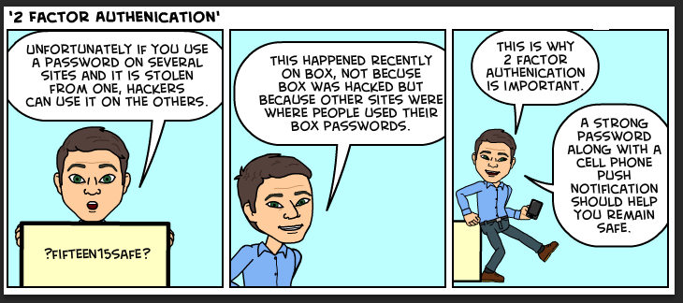

Until next week,

Jim Heston
Coordinator of Academic Technology
Baylor School of Social Work
One Bear Place #97320
Waco, TX 76798-7320
(254) 710-6419

