Prezi
http://prezi.com

Prezi support (manual, FAQ, basics, cheat sheets)
https://prezi.zendesk.com/entries/23448918-Get-Started-with-Prezi

Prezi video tutorial (length 11:23)
http://www.youtube.com/watch?v=CuE0ln8oxYs

Prezi 2013 Features
Navigate the canvas
Getting around your prezi canvas couldn’t be easier.
Zooming around: This is a key feature of Prezi, so naturally we made it simple. You can zoom in and out by using your mouse’s scroll wheel or by clicking the + and - symbols on the right hand side of your screen.
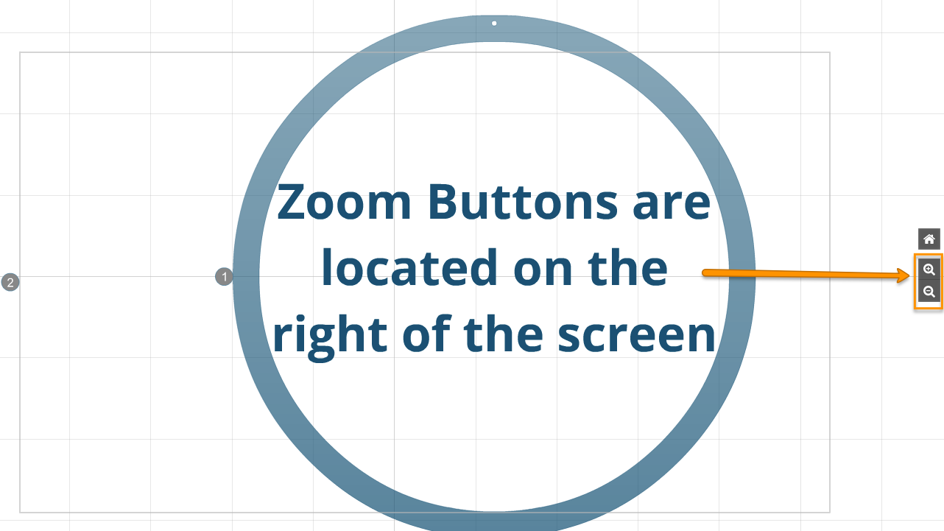
Panning: To move your prezi canvas left, right, up, or down, hold down the left button of your mouse and then move in the direction you want to go.

Get to know the Transformation Tool
In Prezi, the Transformation Tool is your best friend. Once you add anything to your canvas, click on it once to bring up the Transformation Tool. Now you can move, size, and rotate your content any way you like. If you add a frame to your prezi, you can click on it once to bring up the Transformation Tool and move, scale, or rotate everything inside.
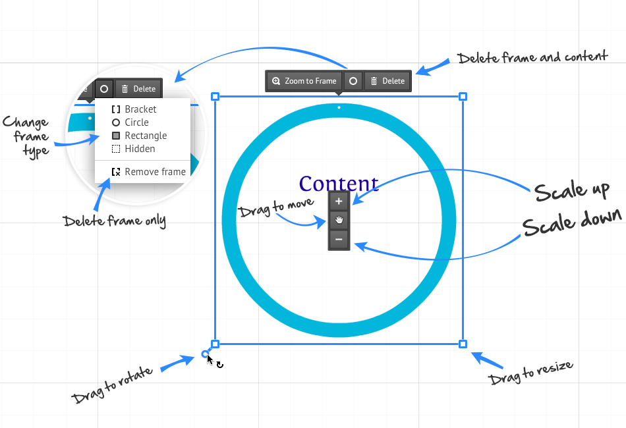

Start from a template
When you create a prezi, you can choose from a number of reusable templates or a blank canvas. When you decide to use a template, you can edit everything you see on the canvas just as if you were creating your own prezi, including copying and pasting pre-made content from other prezis or applications.
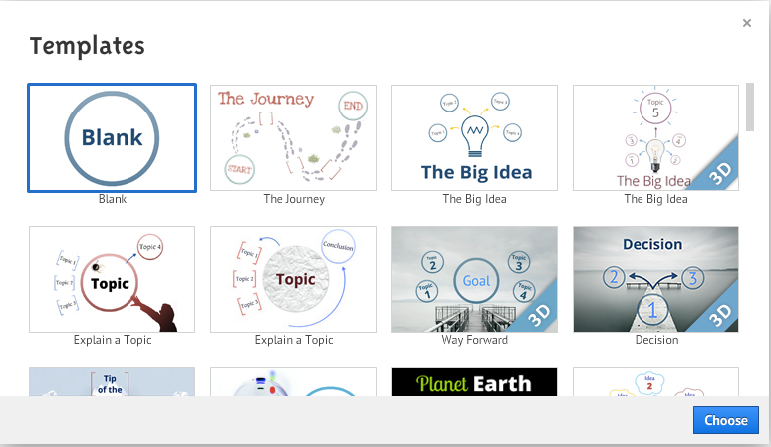

Customize colors and fonts: Theme Wizard
Use the Theme Wizard to customize the colors of your prezi and to set your font choices from Prezi's font library.
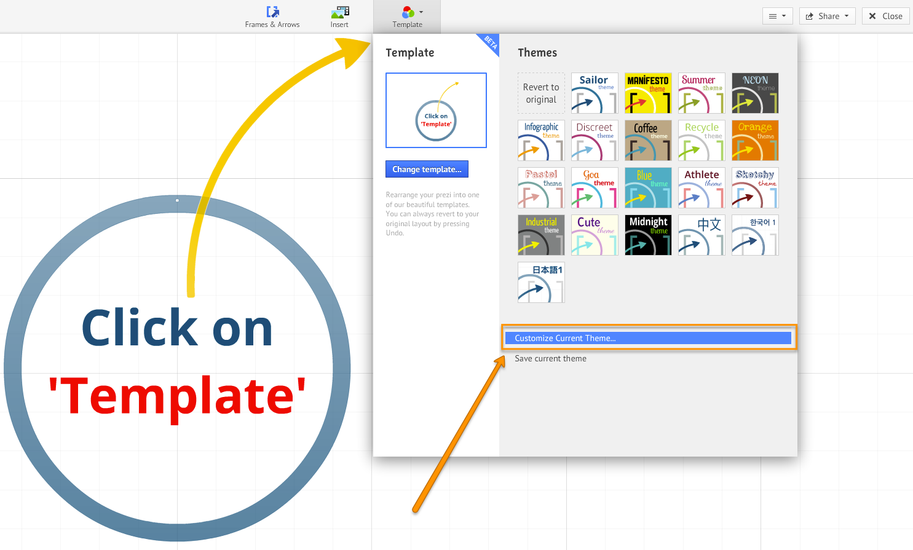
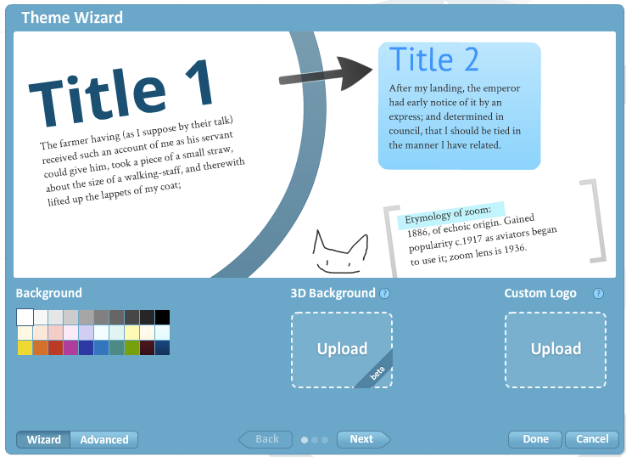
You can also create branded Prezi themes by adding your exact company colors to the wizard. Paying users (Pro, EduPro, Enjoy, and EduEnjoy license holders) can even add their own logo to a customized theme.

Anchor yourself on the canvas: The Home Button
To take a step back and get an overview of everything you've added so far (both in Edit and Present mode), you can use the Home button on the right hand side of your screen (you can find it just above the zoom + and - buttons). Clicking the Home button before you start making a prezi will also ensure that you're starting from the right place.

Frame your content
Frames are a signature part of Prezi and a great way to manage your content. Frames work like slides and can be used to group your ideas. Use frames to create a placeholder in your prezi and then add content to them. Frames come in a variety of shapes and sizes, and you can change the color of them as well as their size and position. The other great thing about frames is that once you place one on your prezi canvas, you can move, size, and rotate it, and all the content within your frame will move, size, and rotate too.
Create frames:
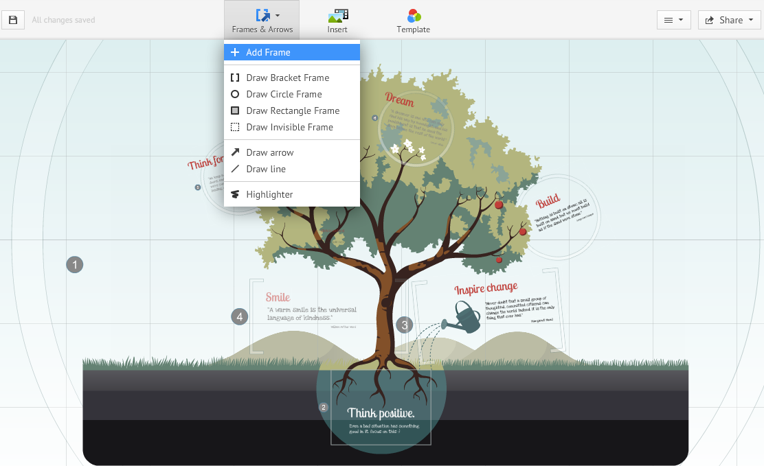
Choose 'Frames & Arrows' from the top menu.
From here you can select 'Add frame' and Prezi will automatically place a frame onto your prezi canvas next to the content that you have been working on. Alternatively, you can select the kind of frame you would like to add from the list. Adding a frame will automatically add another step to your prezi’s path.

Insert diagrams
Prezi has created layout drawings, diagrams, and charts that can help you better communicate your ideas to your audience.
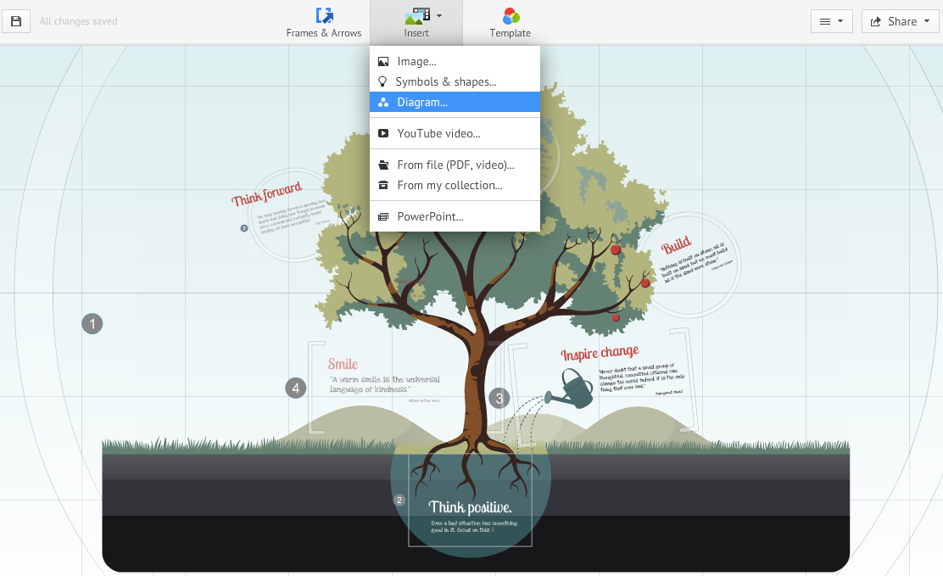
Quickly add content to your drawings, and duplicate them (using the right-click menu or keyboard shortcuts) to start filling your prezi with inspiring content.
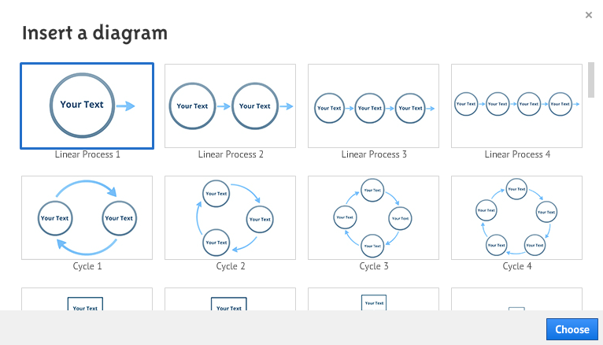

Add symbols and shapes
Click 'Insert' and then select the ‘Symbols and shapes’ icon at the top of the screen to add shapes, lines, arrows, and more to your prezi.
Insert rectangles, circles, and triangles to frame your content. Alternatively, add symbols from a huge library or purpose designed drawings to further enhance your prezi.
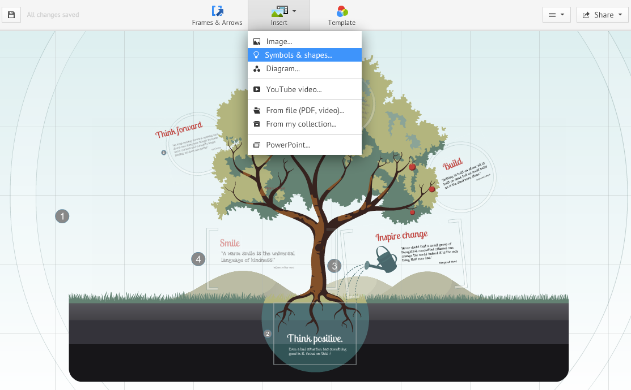

Add URLS to your prezi
To put live links into your prezi, copy and paste the desired URL into a text box. Then click away from the text box and your link will become active (you will see it automatically underline).
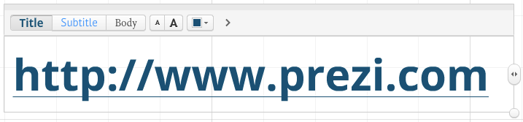

Path points: navigate and rearrange with the Edit Path sidebar
When presenting your ideas, it can sometimes help to have a clear narrative that takes your audience through your prezi. With the Left Sidebar, you can create a journey from one idea to the next. Edit your path and its points in Edit mode and take your audience along that path in Present mode.
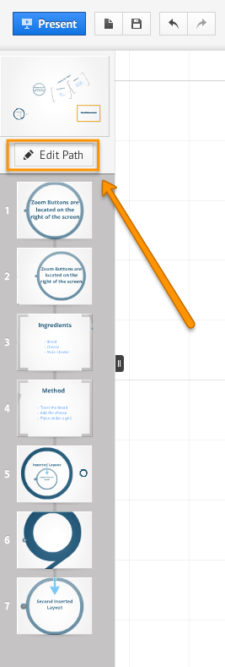
To set your path, click the ‘Edit Path’ button on the left-hand side of screen. Then click on the objects in your prezi canvas in the order you wish them to appear.
You can also use the Edit Path sidebar to add new path points.
Use the sidebar to rearrange and delete path points or to zoom to a specific path point.

“Borrow” from other prezis
On the Prezi Explore page you can find loads of great prezis from which you can “borrow” content, animations or even sound effects. Reusing content in this way allows you to share your ideas more effectively and is a great way to get started with Prezi. To use content from another prezi, first select a reusable prezi you like from the Explore page, then click ‘Save a copy’ to place a copy of the prezi in your own prezi library. From here, you can open the prezi and start putting your own content into it. Alternatively, cut and paste the elements you like into one of your own prezis.

CONTACTS

Jim Heston, Baylor School of Social Work Coordinator of Academic Technology
Office: 254-710-6419 Cell: 254-855-4171
Email: Jim_Heston@Baylor.edu

