Technically Speaking 9-8-14

Faculty friends,

Update
No you didn’t overlook Technically Speaking last week.
I didn’t get one out but hope you enjoy this week’s a little early with a little extra content.

Upcoming SET Session on Social Media in the Classroom
Dr. Ginger Hanchey from the Academy of Teaching and Learning and her her husband Dr. Dan Hanchey from the classics department are leading an upcoming seminar on the approaches to using social media for instructors on November 6th from 12:30-1:30 in Jones 200.
Register here if you are interested: https://www1.baylor.edu/td_reg/ClassDetail.aspx?ClassID=9968

Virtually Speaking
- I’ve been working on updating the BigBlueButton (BBB or Canvas Conferences) section on my http://tech4social.weebly.com/big-blue-button-bbb-or-canvas-conferences.html website, breaking it down into:
  - Basics,
  - Best Practices,
  - Trouble-shooting
- Here’s a trouble-shooting tip we just learned: when you are using BigBlueButton and happen to lose your microphone (even if the test says it is working)
Clear the Flash Cache
1. In the browser you access Canvas, please go to http://www.macromedia.com/support/documentation/en/flashplayer/help/settings_manager06.html
2. Click "Delete All Sites" & "Confirm"
3. Please go to http://www.macromedia.com/support/documentation/en/flashplayer/help/settings_manager04.html
4. Click "Always Ask"
5. Next to "Always trust files in these locations" click the drop down and choose "Delete All Locations" & "Confirm"
6. Next go to http://www.macromedia.com/support/documentation/en/flashplayer/help/settings_manager02.html
7. Click "Always Ask"
8. Next go to http://www.macromedia.com/support/documentation/en/flashplayer/help/settings_manager08.html
9. Click the "Reset License Files" button
10. Restart your browser
11. Log back into Canvas and test.

Engaging Students in Learning
Here are a couple of ideas that speak to student engagement in learning:
- Virtual Spaces: Employing a Synchronous Online Classroom to Facilitate Student Engagement in Online Learning http://www.irrodl.org/index.php/irrodl/article/view/605/1264 "Overall, students in this study were pleased with their learning experiences…our findings indicate three clear problems…too many simultaneous interactions, such as audio, typed chat, and whiteboard/PowerPoint or group questions that could be answered using emoticons, Yes/No, or multiple choice responses…some students found that the lack of non-verbal communication reduced their educational experience. Given the increasing affordability of webcams, this issue might be resolved if the instructor and students installed webcams and used them during their online classes…technology issues, from broken links to faulty headphones, continue to plague synchronous online classes. Institutions of higher learning that are implementing cost-reduction measures must not cut resources for web technicians or for professors who aim to develop high-quality web-based courses if they want to increase their distance learning offerings.
- There is an increasing impetus to create distance learning courses both at the university and secondary school levels, and it is critical for teachers to evaluate the ways in which they deliver online classes, so they can insure that quality does not suffer because of an over-emphasis on convenience. The current study, while not generalizable, suggests that most of our students had a positive online experience using synchronous learning technology. However, their concerns about too much stimuli, their desire for non-verbal communication, and their technological problems must be considered and overcome in order to create a positive learning experience for all students."
- New Study: Engage Kids With 7x the Effect http://www.edutopia.org/blog/engage-with-7x-the-effect-todd-finley?utm_source=facebook&utm_medium=post&utm_campaign=blog-engage-7x-effect-quiz-image
  - Lively teaching
  - academic rigor
  - connective instruction
  - promote relevance
  - convey care
  - concern for student-well eing
  - provide affirmation
  - relate to students with humor
  - enable self-expression
- Problem-Based Learning
is a teaching method in which students gain knowledge and skills by working for an extended period of time to investigate and respond to a complex question, problem, or challenge. Essential Elements of PBL include:
- Significant Content
- 21st century competencies
- In-Depth Inquiry
- Driving Question
- Need to Know
- Voice and Choice
- Critique and Revision
- Public Audience
- NPR TED Talk “Instoppable Learning” http://www.npr.org/2013/04/25/179010396/unstoppable-learning?showDate=2014-08-29 Rita Pierson: Colleague said, "They don't pay me to like the kids." Her response: "Kids don't learn from people they don't like."
- Self-organized Learning Environment toolkit http://www.ted.com/pages/835
"After a series of experiments revealed that groups of children can learn almost anything by themselves, researcher Sugata Mitra began his pursuit to inspire children all over the world to get curious and work together. In 1999, Sugata and his colleagues dug a hole in a wall bordering a slum in New Delhi, installed an Internet-connected PC, and left it there (with a hidden camera). Soon, they saw kids from the slum playing with the computer, learning English and searching through a wide variety of websites on science and other topics, and then teaching each other. His innovative and bold efforts towards advancing learning for children all over the world earned him the first-ever $1 million dollar TED Prize award. In addition to revealing his plan to create a virtual school that offers a child-driven learning experience, he invited thinkers and doers worldwide to create their own miniature self-organized learning environments (SOLEs) and share their discoveries."

Today’s Bitstrip
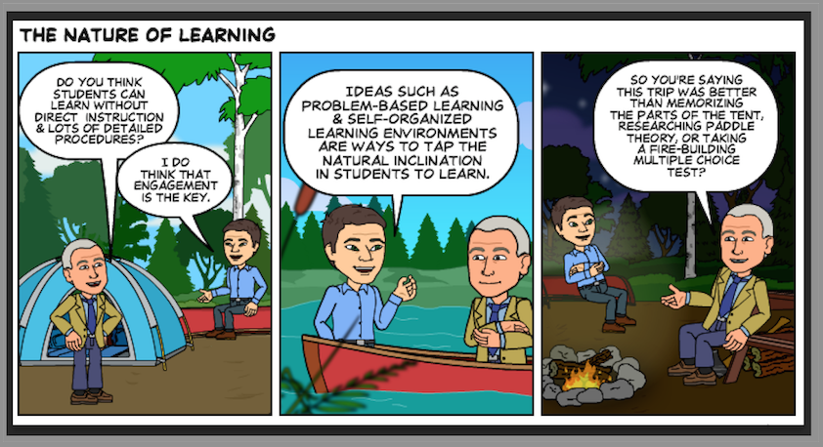

Until next week,

Jim Heston
Coordinator of Academic Technology
Baylor School of Social Work
One Bear Place #97320
Waco, TX 76798-7320
(254) 710-6419

