Technically Speaking 8-15-14

Faculty friends,

SSW Canvas Work Sessions at 811 Washington
With fall classes beginning in about a week, there are a few more work session times in 321 if you have Canvas questions and/or want to come and work on building your courses in Canvas with me and your colleagues:
- Monday, August 18th, from 3:00-4:00pm.
- Wednesday, August 20th, from noon-1:00pm.
- Friday, August 22nd, from 9:00-11:00am.
Don’t forget about the Canvas Help Telephone Hotline available 24/7 for technical assistance: 844-334-0228

Stretching the Canvas (Canvas Tips of the Week)
I mentioned this in a previous newsletter, but I think it worth repeating.
If you want to allow students access to your course before the first day, there is an extra step besides publishing the course and the content pages and modules in the course:
- Under Settings on the left menu¸ you’ll see the second tab, Sections.
- Under Sections, select the desired section.
- Under that section, select the option on your right to Edit Section.
- That will give you access to start/end dates, like those you had with the general course.
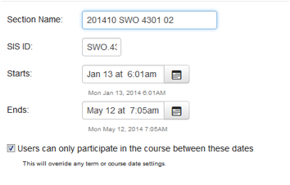

Jabber Accounts
Over the summer, Cisco/Jabber accounts were cleaned up, removing accounts that are no longer needed.
That said, please have Jabber users check their accounts a few days before a connection so that I can create a new account for them if needed.

Today’s Bitstrip
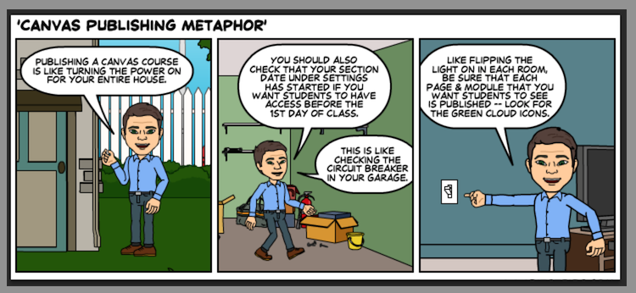

Until next week,

Jim Heston
Coordinator of Academic Technology
Baylor School of Social Work
One Bear Place #97320
Waco, TX 76798-7320
(254) 710-6419

