Technically Speaking 7-9-14

Faculty friends,

SSW Canvas Trainings/Workshops at 811 Washington
The Electronic Library will be working with me to host a Canvas Course make-over session just for SSW faculty in room 321 on both (bring your laptop, syllabus, and a few few course documents.):

- Wednesday, July 9th, from 2:00-4:00 pm
- Thursday, July 17th, from 9:00-11:00 am.

I will also host informal brown bag workshop times also in 321 (come-and-go) to be available if you want to come and work on building your courses in Canvas with me and your colleagues:
- Monday, July 21st, from noon-1pm.
- Wednesday, July 30th, from noon-1pm.
- Monday , August 4th, from noon-1pm.
- Wednesday, August 13th, noon-1pm.

Overcoming
If any of you have interest in the topic of Overcoming, NPR’s Ted Radio Hour had an interesting program that describe "stories of overcoming a weakness and turning it into a strength:” http://www.npr.org/programs/ted-radio-hour/?showDate=2014-07-03

Open Educational Resources
Here’s a link to a website (http://campustechnology.com/articles/2014/07/02/16-oer-sites-every-educator-should-know.aspx) that lists/describes some resources that you might find useful:
- College Open Textbooks
- Learingpod
- Lumen Learning
- MERLOT II
- MIT Open Courseware Online Textbooks
- OER Commons
- Open Course Library
- Open Education Consortium
- Open Learning Initiative
- OpenStax CNX
- OpenStax College
- OpenTextBookStore
- Saylor.org
- Spiral Physics
- Teach Astronomy
- The Orange Grove

Video-Conferencing Norms
On my website Tech4Social (http://tech4social.weebly.com/norms.html), I list some basic norms for virtual synchronous learning:
Before a class begins:
o Test that needed technology works (especially if using new hardware, software, or location).
o Watch video tutorials when available.
o Maximize the connection by:
§ Plugging into a power source.
§ Plugging into an Ethernet cable (if unable, getting as close to a wireless router as possible).
§ Closing unneeded programs.
o If sharing video:
§ check self-view by ensuring your face is framed/angled appropriately
§ and not in shadow (don’t sit with back to sunny window, have a light on in front of you).
o If sharing audio:
§ Minimize extraneous noises.
§ Use headphones.
§ Mute when not talking.
Treat the session as much like a normal meeting/class as possible:
o Respect start and end times.
o Listen, participate, and maintain eye contact.
o Avoid unrelated activities (you probably wouldn't iron clothes in a meeting or classroom).
Respect the specific etiquette for each class/instructor.

Today’s Bitstrip
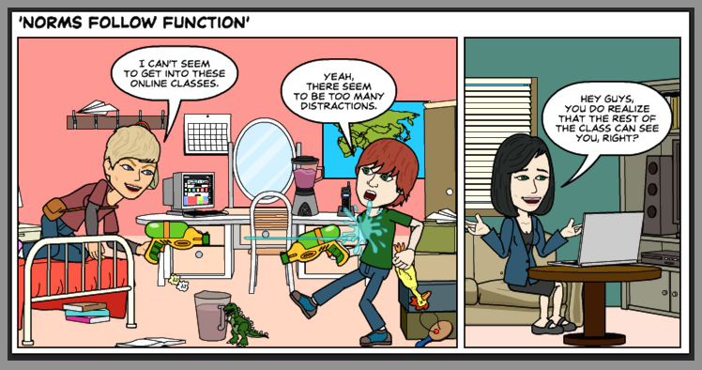

Until next week,

Jim Heston
Coordinator of Academic Technology
Baylor School of Social Work
One Bear Place #97320
Waco, TX 76798-7320
(254) 710-6419

