Technically Speaking 7-23-14

Faculty friends,

SSW Canvas Work Sessions at 811 Washington
I will continue to host informal brown bag work session times in 321 (come-and-go) to be available if you want to come and work on building your courses in Canvas with me and your colleagues:
- Wednesday, July 30th, from noon-1pm.
- Monday , August 4th, from noon-1pm.
- Wednesday, August 13th, noon-1pm.

Additional Canvas Support
- Feel free to contact Baylor’s Online Teaching & Learning (OTL) temporary consultant Adrienne Steely (adrienne_steely@baylor.edu); I know a few of you have had her come to work with you one-on-one building your Canvas courses.
- The Canvas technical support hotline is now available 24/7 to answer your questions as well: 844-334-0228.
- The OTL is often adding to Canvas resources here: http://www.baylor.edu/canvas/index.php?id=865034
- John Solis from OTL came last Thursday to introduce our faculty to Canvas. Even though this wasn’t intended for a video audience, you might find the recording I made of this helpful: http://youtu.be/ZvQRXXJN4Sg
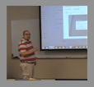

BearSpace Accounts Ending
There was an announcement last week that BearSpace accounts will begin to be locked in January 2015 so if you haven’t already joined Box and moved your files into Box, I suggest you begin that process soon (http://www.baylor.edu/its/index.php?id=94642).

Online Pedagogy
Magna Newsletters has an article called "Five Pedagogical Practices to Improve Your Online Course” (http://ww1.magnapubs.com/eletter/profile/123/150.html?ET=magnapubs:p150:845511a:&st=pmail).
Again, like most literature regarding online learning, this article assumes a mostly asynchronous environment, but there is sound advice that applies to either format.
The practices include (click the link above for details on each):
- Vary the learning experiences.
- Have successful discussions.
- Plan a closing or wrap-up activity.
- Provide personal feedback.
- Ask students for feedback.

Today’s Bitstrip
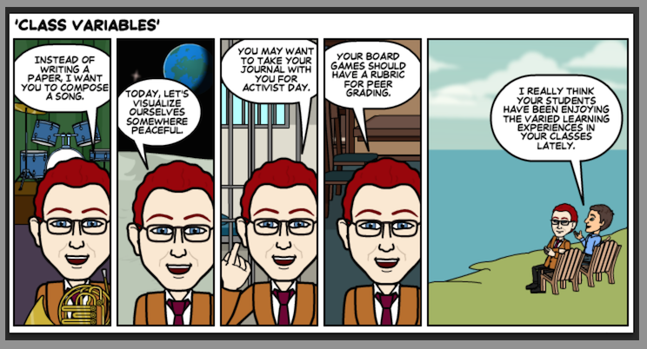

Until next week,

Jim Heston
Coordinator of Academic Technology
Baylor School of Social Work
One Bear Place #97320
Waco, TX 76798-7320
(254) 710-6419

