Technically Speaking 7-16-14

Faculty friends,

SSW Canvas Trainings/Workshops at 811 Washington
The Electronic Library will be working with me to host a Canvas Course make-over session just for SSW faculty in room 321 on (bring your laptop, syllabus, and a few few course documents. We will differentiate content for those who came last week.):

- Thursday, July 17th, from 9:00-11:00 am.

I will also host informal brown bag workshop times also in 321 (come-and-go) to be available if you want to come and work on building your courses in Canvas with me and your colleagues:
- Monday, July 21st, from noon-1pm.
- Wednesday, July 30th, from noon-1pm.
- Monday , August 4th, from noon-1pm.
- Wednesday, August 13th, noon-1pm.

Graphic Novel Use in Higher Ed
The ActiveWriter.com lists 5 graphic novels (long form comic book literature) with social commentary: http://theactivistwriter.com/2010/11/04/five-graphic-novels-packed-with-social-comment/
If you are interested in engaging students using more diverse literature forms (especially visual learners), you might want to check out Graphic Novels in the Classroom:Essays on the Educational Power of Sequential Art by Carrye Syma and Robert Weiner 2013: http://www.amazon.com/Graphic-Novels-Comics-Classroom-Educational/dp/0786459131.
Topics include:
- history of the form,
- intertexuality,
- parody,
- interdisciplinary texts,
- multicultural themes,
- feminism,
- and qualitative research.
I’ve also attached an article from The Alan Review called “Graphic Novels, New Literacies, and Good Old Social Justice” by Gretchen Schwartz 2010.

iTunesU
iTunes U (available through http://www.apple.com/itunes/) have higher ed resources (mostly free) including lectures and guest speakers on many topics including social work related issues (look for the Pychology & Social Science category) such as:
- “Death and Dying”
- “What Defines Sexuality”
- “Justice, Vengeance, and Forgiveness”
- “Sustainable Communities”
- “Human Trafficking”
- “Rights and Vulnerable People”
Once you have IiTunes, go to the iTunes Store, then find iTunes U on the right of the top menu bar.
There is also a free app for iPads that allows access to host class discussion as well as text resources and photos and video from the iPad camera: http://campustechnology.com/articles/2014/07/02/updated-itunes-u-brings-course-tools-to-ipad.aspx.

Guide to Online Course Design
I had mentioned that I have a few books on instructional design in my checkout library.
One of them I really like is called A Guide to Online Course Design: Strategies for Student Success by Tina Stavredes and Tiffany Herder 2014:
(http://www.amazon.com/Guide-Online-Course-Design-Strategies/dp/1118462661).
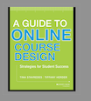
I have attached one additional resource that goes along with the book that talks through the ADDIE (analyze, design, develop, implement, and evaluate) method of instructional design.

Today’s Bitstrip
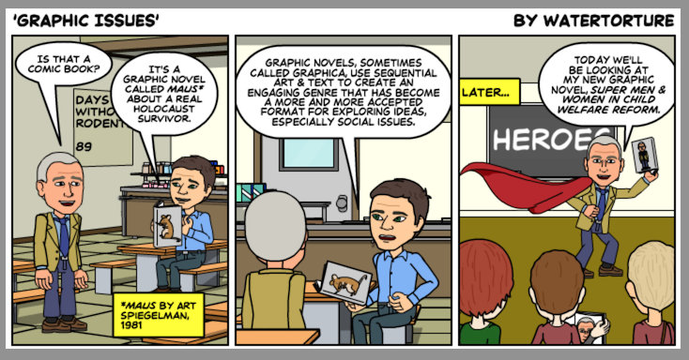

Until next week,

Jim Heston
Coordinator of Academic Technology
Baylor School of Social Work
One Bear Place #97320
Waco, TX 76798-7320
(254) 710-6419

