Technically Speaking 7-1-14

Faculty friends,

SSW Canvas Training at 811 Washington
The Electronic Library will be working with me to host a Canvas Course make-over session just for SSW faculty in room 321 on both:
- Wednesday, July 9th from 2:00-4:00 pm
- Thursday, July 17th from 9:00-11:00 am.

Feel free to come to either of both of these opportunities.
These sessions will be both informational and workshop time for assistance as you explore Canvas course building.
If you haven’t already, request a Canvas account: http://www.baylor.edu/canvas/index.php?id=865026 now.
I’ll send out Outlook invitations soon.

Canvas Student Orientation
You may have received a message inviting you to the Student Orientation – SSW course in Canvas.
Marilyn, Charletra, Jon, and others have been helping me get this going.
It was originally created by the Electronic Library for the online MBA program, and we have modified it for our School’s use.
It includes these modules: Introduction to Canvas, Learning Online (including info on BBB & Jabber), Student Resources, Library & Research, and Academic Integrity. Most of the modules have a simple quiz, some have embedded videos, most have links to important resources.
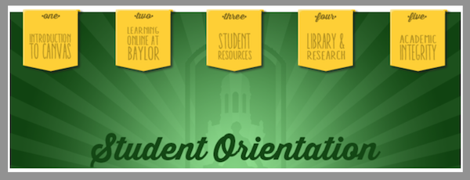
Feel free to go through it yourself to both see what students are seeing and see an idea of what Canvas modules can look like.

Canvas Courses
Speaking of Canvas courses, Sam Vo let me know yesterday that she just happened to look in Canvas (https://baylor.instructure.com) and saw that her fall courses were loaded (she said that she did not receive a notification).
I haven’t found out for sure if all courses are there, but, if you’re interested, you can check.

Today’s Bitstrip
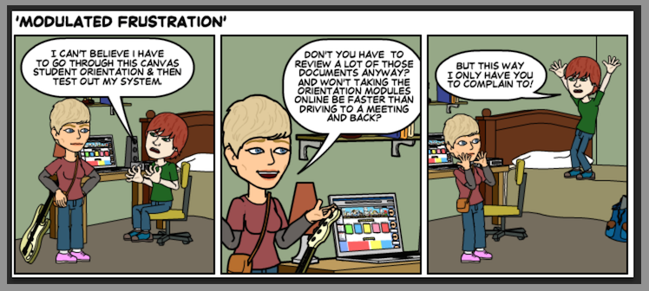

Until next week,

Jim Heston
Coordinator of Academic Technology
Baylor School of Social Work
One Bear Place #97320
Waco, TX 76798-7320
(254) 710-6419

