Technically Speaking 6-27-14

Faculty friends,

SSW Canvas Training at 811 Washington
The Electronic Library will be working with me to host a Canvas Course make-over session just for SSW faculty in room 321 on both:
- Wednesday, July 9th from 2:00-4:00 pm
- Thursday, July 17th from 9:00-11:00 am.

Feel free to come to either of both of these opportunities.
These sessions will be both informational and workshop time for assistance as you explore Canvas course building.
If you haven’t already, request a Canvas account: http://www.baylor.edu/canvas/index.php?id=865026 now.
I have attached a worksheet that describes some of the differences between Canvas and BlackBoard.

Scaffolding
When you introduce an assignment, do you give students sample models so that can see an example of what you expect or do you feel like students may just copy what you have shown and thus stifle their creativity?

I struggled with this issue and often hesitated giving examples, but eventually, through experience, learned to find great professional level examples of what I wanted students to do — or better yet create an example myself. I learned how to be specific and explain how the type of product I wanted from them but that I wanted them to do more than copy it, how they should try to find a different type of product that could do the same thing or add to my example by bringing in other sources (synthesize).

On the Department of Educational Psychology and Instructional Technology, University of Georgia's website Emerging Perspectives on Learning, Teaching, and Technology, Kao, Lehman, & Cennamo (1996) discuss hard (static) and soft (dynamic) scaffolds for higher education (http://epltt.coe.uga.edu/index.php?title=Scaffolding#Adult_and_Higher_Education) and how these students have a dual role as student and peer.
Edtopia expounds upon scaffolding strategies here: http://www.edutopia.org/blog/scaffolding-lessons-six-strategies-rebecca-alber

If you have concerns regarding originality when using examples, the TED Radio Hour has an interesting podcast called “What Is Original?” (52 minutes, http://www.npr.org/programs/ted-radio-hour/; if it is no longer on the front page search by title) that focuses on music sampling but then moves into many genres of creation. They mention a song called “Four Chords” that shows how music builds upon previous works (https://www.youtube.com/watch?v=oOlDewpCfZQ; you can avoid the expletive by stopping at 5 1/2 minutes in).

Today’s Bitstrip
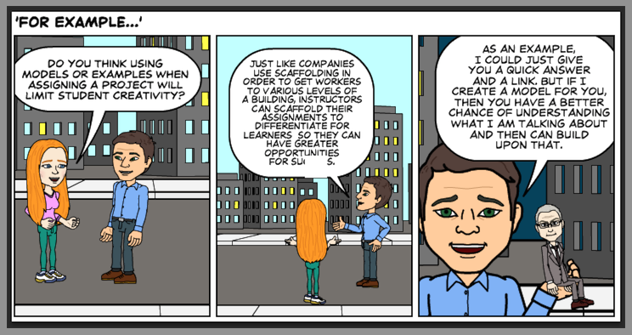

Until next week,

Jim Heston
Coordinator of Academic Technology
Baylor School of Social Work
One Bear Place #97320
Waco, TX 76798-7320
(254) 710-6419

