Technically Speaking 6-19-14

Faculty friends,

Canvas’ Video-Conferencing App BigBlueButton
With dates for SSW Canvas trainings coming very soon (hopefully an announcement next week), I’d like to also share some information regarding its alternative to BlackBoard Collaborate (formerly Elluminate), Jabber, and Skype.
It’s called BigBlueButton (sometimes just BBB), but in Canvas is listed as Conferences in the menu. There is some talk about adding Collaborate into Canvas as well, but trainings and loading courses are a higher priority for the electronic library folks.
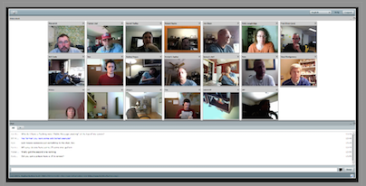
I have some resources on my webpage here: http://tech4social.weebly.com/canvas-big-blue-button.html .
Like Collaborate — but unlike Jabber — BBB does not need to be scheduled with me or the BU; there are unlimited “seats,” though 25 participants is the recommended max. However, like Collaborate, BBB does not work through our Jabber carts.
Here’s a short (8:58) video tutorial for BBB: https://www.youtube.com/watch?v=PHTZvbL1NT4&feature=youtu.be

Box
Not only will BlackBoard be going away summer 2015 being replaced by Canvas with an overlap from now until then, BearSpace (BU cloud storage) is also going away summer 2015 being replaced by Box (similar to but not DropBox) with an overlap from now until then.
Faculty, staff, and students will have personal Box storage space. Faculty and staff can request access to the SSW Box where documents can easily be shared.
Some of the SSW will continue to use the SSW s-drive because it allows them to easily share documents without overwriting them, but these items will also be copied into the SSW Box.
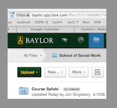
SSW BearSpace files are — as I type — being cleaned up and migrated over to SSW Box.
We recommend creating your Box account now http://www.baylor.edu/its/index.php?id=94642; once you have, let me know so I can send an invitation to you to join the SSW Box.

Devices in Class
One topic of note lately is whether students bringing laptops to class is a benefit. Some say students perform better when taking notes with pen and paper while laptops create too many distractions. Students claim that laptops benefit their learning and offer multiple tools for classroom use. However, I think most of these studies use a large lectured-centered class as the default of the study.
Various articles follow:
- http://www.boston.com/health/2014/06/05/take-note-this-handwritten-notes-are-more-effective-than-typed-ones/Ypp4ahKuX2Zd0OtUqBw79H/story.html
- http://www.newyorker.com/online/blogs/elements/2014/06/the-case-for-banning-laptops-in-the-classroom.html?mobify=0
- http://lifehacker.com/5738093/why-you-learn-more-effectively-by-writing-than-typing
- http://pss.sagepub.com/content/25/6/1159.full.pdf+html
- http://www.huffingtonpost.com/wray-herbert/ink-on-paper-some-notes-o_b_4681440.html

Today’s Bitstrip
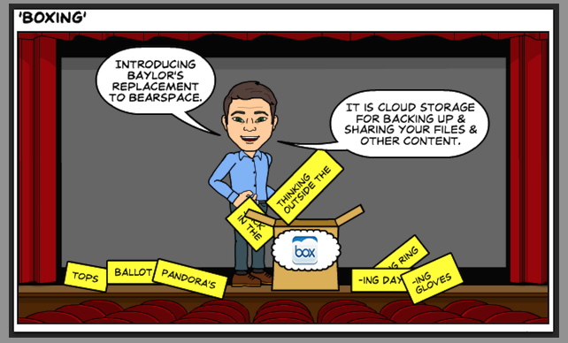

Until next week,

Jim Heston
Coordinator of Academic Technology
Baylor School of Social Work
One Bear Place #97320
Waco, TX 76798-7320
(254) 710-6419

