Technically Speaking 6-11-14

Faculty friends,

Transition to Canvas Update
As you know, Baylor is transitioning from BlackBoard LMS to Canvas. While BlackBoard will be available until summer 2015, we are recommending the use of Canvas as soon as possible, especially for MSW and PhD courses.
We recommend taking any of the on-campus courses, info and registration https://www1.baylor.edu/td_reg/BrowseAll.aspx), including:
- 6/12 2:00-3:00 "7 Things To Know about Canvas"
We are working on a Canvas Course Make-over session at 811 Washington tailored for social work sometime in early July.
I plan to host a few additional Canvas work sessions (brown bags?) in July and August.
You can find out more about Canvas and/or register for demo course account (http://www.baylor.edu/lib/factech/index.php?id=863026) and watch video tutorials/guides of Canvas (http://guides.instructure.com/m/4210).

Away Message in Outlook
If you want to create an away message in Outlook so people know when you probably won’t be checking email, you can find instructions here:
- PC: http://support.microsoft.com/kb/290846
- Mac: http://blink.ucsd.edu/technology/email/tasks/out-office-2011.html#2.-Auto-reply-to-external-email
By the way, I’ll be off on a short vacation starting tomorrow and be returning to my office Tuesday.

Taking a Screen Capture
If you ever want to copy all or part of your computer screen, try the links below.
- PC: http://m.wikihow.com/Take-a-Screenshot-in-Microsoft-Windows
- Mac: http://support.apple.com/kb/HT5775?viewlocale=en_US&locale=en_US
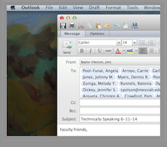
I find that using this is a great tool to use if you need to share an error message, show someone how to get to something in a program, or copy a picture off the internet.

Googling
13 Google Search Tricks: http://www.huffingtonpost.com/2014/05/30/google-search-tricks_n_5338470.html
  - define a word
  - search for words in exact order
  - exclude certain words
  - search within a range of prices
  - search within a website
  - fill in the blanks
  - search by file type
  - set a timer
  - do math
  - convert currency
  - find a gif
  - search by title
  - make Google flip out

Today’s Bitstrip
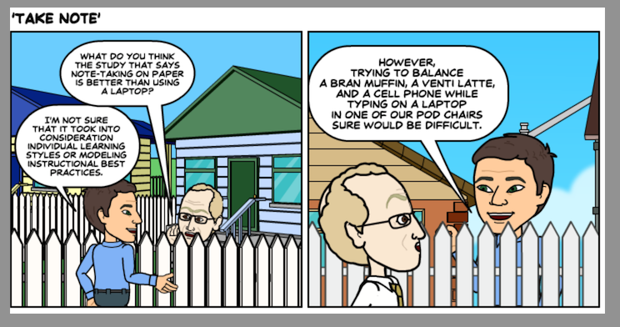

Until next week,

Jim Heston
Coordinator of Academic Technology
Baylor School of Social Work
One Bear Place #97320
Waco, TX 76798-7320
(254) 710-6419

