Technically Speaking 5-14-14

Faculty friends,

Upcoming Trainings
- May 19-21 Course Make-over Workshop by the Academy of Teaching & Learning

PechaKucha Presentations
There is an interesting movement to simplify presentations using a style called PechaKucha, Japanese for “chatter" (http://www.pechakucha.org).
It’s not new software; it’s a way to get a point across quickly and concisely.
The format is to use 20 slides (often without text) that are shown for 20 seconds each (6:40 total).
Here’s an example: http://www.pechakucha.org/presentations/from-billboards-to-changed-lives.
Sam Vo recommended this process to me and has used it successfully with her students.

Flipped Classroom Webinar
Echo 360 hosted a webinar called “Flipping without Flopping” last week; find a recording of it here: http://bit.ly/1k1l3wQ
I have attached an article and infographic that are included with the webinar as resources.

Baylor’s Online Software Directory
If you are wondering if you have free access to software through Baylor, you can go to or recommend that your students visit the Baylor Software Directory: http://www.baylor.edu/its/index.php?id=44648.
There are over 50 programs (including atlas.ti, Qualtrics, and SPSS) listed alphabetically.
It tells you if the software is available:
- free or at a cost,
- limited authorization access,
- and Mac/ PC platform availability.
It also states if it is available for:
- faculty/staff,
- faculty/staff home use,
- students,
- and computer labs.
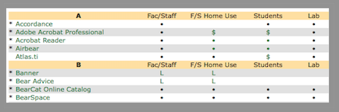

Google Hangout
Google Hangout (http://www.google.com/+/learnmore/hangouts/) is another video-conference option.
It is a free option and can conference with up to 10 people.
There is more info on the attached Cheat Sheet.
Here’s a tutorial video my GA Hannah created: http://youtu.be/1O3z0y6acAw
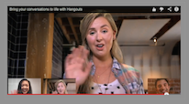

Adobe Voice for iPad
For those of you that have access to an iPad or for your students that have one, there’s a new free app called Adobe Voice that combines voice, images, and music to create a slick presentation.
See the promo video (1:29): http://youtu.be/I6f0XMOHzoM, visit their website http://getvoice.adobe.com/?gclid=CKGw5f_Vq74CFVQiMgod7RwAtA, or search for Adobe Voice in the App Store on an iPad.

Lecture Effectiveness
According to the Proceedings of the National Academy of Sciences of the United States of America, “Lectures Aren’t Just Boring, They’re Ineffective, Too” http://news.sciencemag.org/education/2014/05/lectures-arent-just-boring-theyre-ineffective-too-study-finds.
They suggest active learning approaches such as using clickers or random name calling instead (many more listed here: http://web.calstatela.edu/dept/chem/chem2/Active/main.htm).
The study also found that "there was no difference in being lectured at in a classroom versus through a computer screen at home. So…'If you’re going to get lectured at, you might as well be at home in bunny slippers.’"

We’ll Miss You Guys
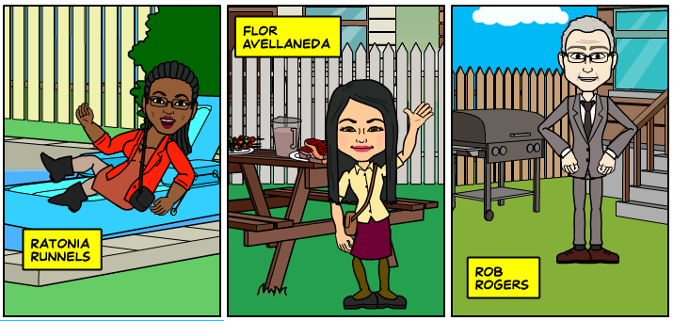

Until next week,

Jim Heston
Coordinator of Academic Technology
Baylor School of Social Work
One Bear Place #97320
Waco, TX 76798-7320
(254) 710-6419

