Technically Speaking 4-23-14

Faculty friends,

Trainings
- 04/25/14 Juggling Elephants: Priority & Time Management 1:00-4:00pm

Classroom Speakers for iPhone/iPad
If you want to amplify your iPhone so that others in the room can hear the speaker on the other line or if you want to play music from your iPhone or iPad, you can plug in the audio cable that is attached to the VGA cable in each classroom to access the projector speakers, but first you will have to plug the VGA cable into a computer. This is a work-around — the projector won’t know where the sound is coming from but won’t access the sound unless a computer is plugged in.

High Yield Teaching Practices
Many of you will be planning to refresh or create new curriculum this summer. As you do, the following best practices (adapted by me for higher ed from the research-based k12 best practices from http://www.leadyourschool.com) may prove helpful:
- arrange the classroom to enhance activity
- ensure students understand activity purpose
- increase rigor using Bloom’s vocabulary: http://bit.ly/1mwQW0b
- show relevance across content areas & into real world non-predictable settings
- pose questions for students as they prepare to leave the class to check for understanding
- vary student responses: oral, written (multiple choice, short answer, essay), corporate, performance, thumbs-up, etc.
- use positive language
- provide recognition & reinforce effort
- use technology appropriately
- model through the use of examples, cues, & organizers
- provide frequent, specific feedback
- encourage the use of:
  - identifying similarities & differences
  - written summaries
  - non-linguistic representation
  - generating & testing hypotheses
  - cooperative learning & discussion groups
  - student to student feedback

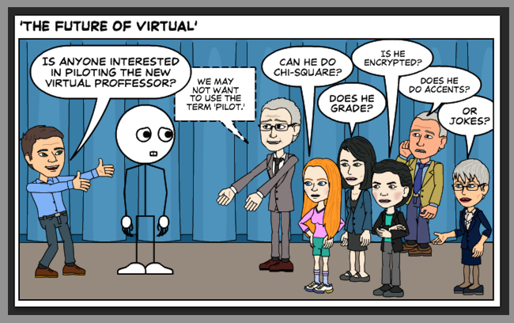

Until next week,

Jim Heston
Coordinator of Academic Technology
Baylor School of Social Work
One Bear Place #97320
Waco, TX 76798-7320
(254) 710-6419

