Technically Speaking 10-8-14

Faculty friends,

Memes
If you are looking for a conversation starter, you might think of sharing an internet-style meme with your class.
You could also have students create their own.
You can use this site http://memegenerator.net to look for examples or make your own like the one below:

Infographic
I had mentioned that if you or your students are interested in creating drag-and-drop info graphics, www.easel.ly is a pretty good place to start.
They also have recently added some http://www.easel.ly/blog/new-feature-charts/.
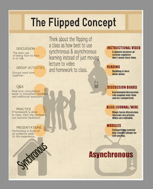

TurnItIn: Student Success Week
TurnItIn has some free webinar resources that are available live or archived.
You can find a summary here http://turnitin.com/en_us/resources/student-success-week.

October 6 "The Wealth in Words": Vocabulary and Social Inequality
Join us for this unique conversation with noted education reformer, E.D. Hirsch, Jr. as he shares with us his insights into the importance of content-based instruction and how the teaching of vocabulary can affect change in our educational system.Register
October 7 The Gamification of Learning: Producing Tighter, More Timely Feedback for Increased Student Success
In this webcast, Zandree Stidham (Department Chair of Communications at the University of New Mexico) will share current research behind the gamification of learning, discuss the intersection of gaming and student engagement, and share strategies for deploying game-based approaches in the classroom. Register
October 8 The Place of Feedback in High-Stakes Assessment
Join us for a conversation with Wayne Camara, the Senior Vice President, Research at ACT® as he shares insights into the connections between high-stakes assessment, feedback and standards. The interview will cover topics such as the importance of standards alignment, how feedback might look in the near future and the benefits for students. Register
October 9 Students Feed Back: Student Perceptions of Instructor Feedback
What do students really think about the feedback that they receive? Join us for a special session where we'll surface student insight into the approaches, strategies, and mediums that students find most effective in helping them improve their work. Register
October 10 Dial Up and Dialed In: Engaging the Digital Student
In this session, Kelley Brumbelow (Georgia Virtual School) shares her strategies for engaging students in an online-only classroom. Brumbelow will discuss how setting expectations, providing interactive videos for feedback, and leveraging standardized rubrics all serve to increase the effectiveness of feedback. Register

Today’s Bitstrip
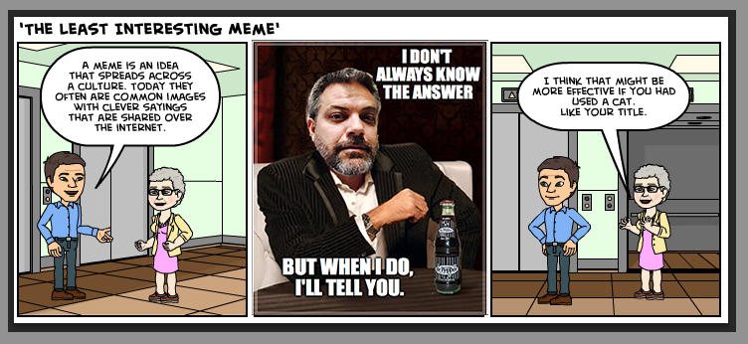

Until next week,

Jim Heston
Coordinator of Academic Technology
Baylor School of Social Work
One Bear Place #97320
Waco, TX 76798-7320
(254) 710-6419

