Technically Speaking 10-23-14

Faculty friends,

Flipped Classroom
Campus Tech had an interesting article on flipped classroom strategies (http://pdf.101com.com/CampusTech/2014/701920707/CAM_1410DG.pdf).
Here’s a summary:
- Just-in-Time Teaching: "getting students to prepare before coming to class…uses formative assessment to determine students’ understanding…and plan accordingly…[start with] a reading, watching a video or other activity…[then] develop a formative assessment, consisting of two ‘conceptual questions’ and one ‘feedback question’ [like] What do you find most difficult or most confusing or interesting about this concept"
- Peer Instruction: “instructor gives ‘mini-lecture’…students are asked a question related to the topic that expands their thinking…[students] try to convince fellow students of the rightness of his response…students respond to the same question again…correct answer is shared by the faculty…students are invited to share why they chose the answer they did…a longer explanation is provided"
They also have tips on BLENDED COURSE DESIGN:
- Plan for Accessibility, Don’t Retrofit
- Don’t Assume Students AreInternet Savvy
- Build for Cognitive Access
- Rethink Content for Engagement
- Make Students Feel Like You’re There

“Learning Strategies” talk by Dr. Charles Weaver
Here’s the link to Dr. Charles Weaver’s talk from Tuesday's Brown Bag: http://youtu.be/w22EoHy-0Xw (1 hour, 13 minutes).
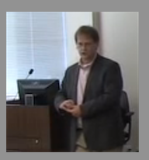

Thinking Fast and Slow by Daniel Kahneman 2011
You might find some the insights from Kahneman’s book interesting and applicable (he even discusses learning styles):
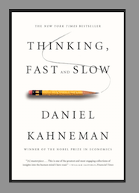
- "you dispose of a limited budget of attention that you can allocate to activities, and if you try to go beyond your budget, you will fail” p 23
- "if you have had to force yourself to do something, you are less willing or less able to exert self-control when the next challenge comes around. The phenomenon has been named ego depletion.” pp 41-42
- "when people believe a conclusion is true, they are also very likely to believe arguments that appear to support it.” p 45
- "children who show more self-control as four-year-olds had substantially higher scores on tests of intelligence.” p 47
- When you feel strained, you are more likely to be vigilant and suspicious, invest more effort in what you are doing, feel less comfortable, and make fewer errors, but you also are less intuitive and less creative than usual. p 60
- "A reliable way to make people believe falsehoods is frequent repetition.” p 62
- “...before an issue is discussed, all members of the committee should be asked to write a very brief summary of their position. This procedure makes good use of the value of diversity of knowledge…The standard practice of open discussion gives too much weight to the opinions of those who speak early and assertively…” p 85
- "there is no such thing as a hot hand in professional basketball.” p 116
- "the tendency to see patterns in randomness is overwhelming.” p 117
- "if the content of a screen saver on an irrelevant computer can affect your willingness to help strangers without being aware of it, how free are you? [anchoring] p 128
students who listed more ways to improve the class trated it higher.” p 133
- "for laypeople…probability…is a vague notion, related to uncertainty, propensity, plausibility, and surprise.” p 150

Today’s BitStrip
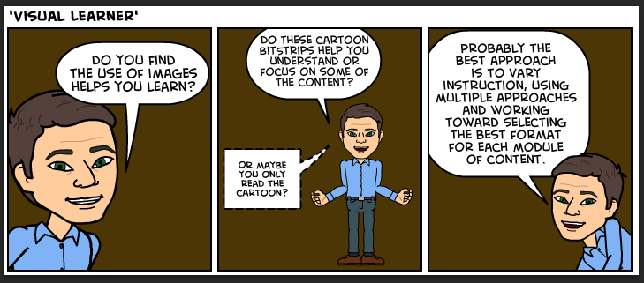

Until next week,

Jim Heston
Coordinator of Academic Technology
Baylor School of Social Work
One Bear Place #97320
Waco, TX 76798-7320
(254) 710-6419

