How To Install & Use Skype

- Go to http://www.skype.com/en/download-skype/skype-for-computer/ and download the appropriate software:
  - Mac - http://www.skype.com/en/download-skype/skype-for-mac/downloading/
  - Windows 8 - http://www.skype.com/en/download-skype/skype-for-windows8/
  - Windows Desktop (XP, Vista or 7) - http://www.skype.com/en/download-skype/skype-for-windows/
  - Linux - http://www.skype.com/en/download-skype/skype-for-linux/
- You will be asked to create a Skype Account and Log-in information (Skype Name and Password) once software is installed on your computer.
- You may need to restart your computer to complete installation.
- Enter Log-in information:

- Under the “home” page tab, you can view recent status updates by contacts and provide a status update to your contacts.
- Under the “contacts” tab, you can view a complete list of contacts including their statuses - online, offline, away, do not disturb. Click on “Add Contact” to add new contacts:
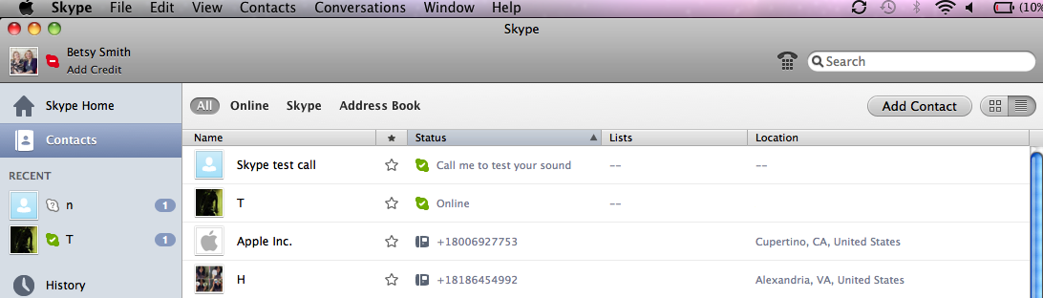
You can search for contacts by full name, email address, and Skype name. Click on the green Add Contact button to add the contact to your list:

- To perform a test call and make sure your webcam (video) and mic* (audio) are working properly, call “Skype test call”:
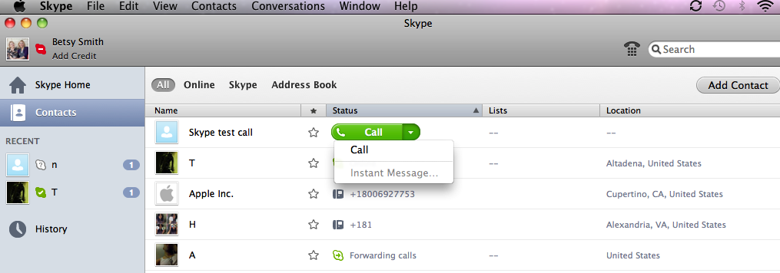
*A computer must have a webcam and mic to use video/audio features.

- To place a call with a contact who is online, place your cursor on the contact status, and choose one of the call options (Video Call, Call, Mobile*):
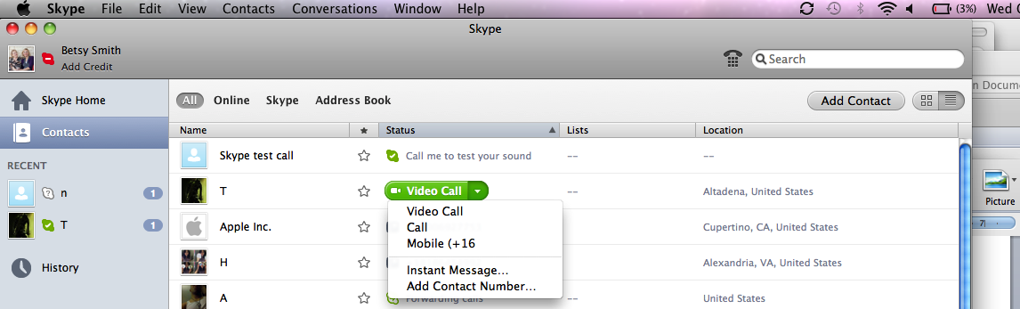
*Not all contacts have a Mobile option, which calls a cellphone that is connected to Skype.

- To answer an incoming call, click on the Green Video (if you have a webcam) button or the Green Phone button (for audio only call). To reject an incoming call and redirect caller to a voicemail box, click on the Red Phone button:

- Options during the call:
- You may rearrange video windows by clicking on the screens dragging the boxes to a desired location on the screen. You may also adjust the sizes of the windows by clicking on the corners of the windows.
- Menu Options:
- Open and close the side bar to view contacts or recent history.
- Turn video on or off.
- Mute your microphone.
- Send files, send contacts or share your screen with the person you are calling. Add more people to the video call (requires additional subscription) or send an Instant Message.
- Enter full screen mode.
- Click on the Red Phone button to End the call:
- To instant message, see the following website for instructions for various devices:
https://support.skype.com/en/faq/FA10808/sending-instant-messages-mac
- To trouble-shoot audio/video:
On a Mac:
Click on Skype tab next to the Apple icon and then on Preferences in the dropdown menu
.
Click on the Audio/Video tab on the pop-up window to test or select.
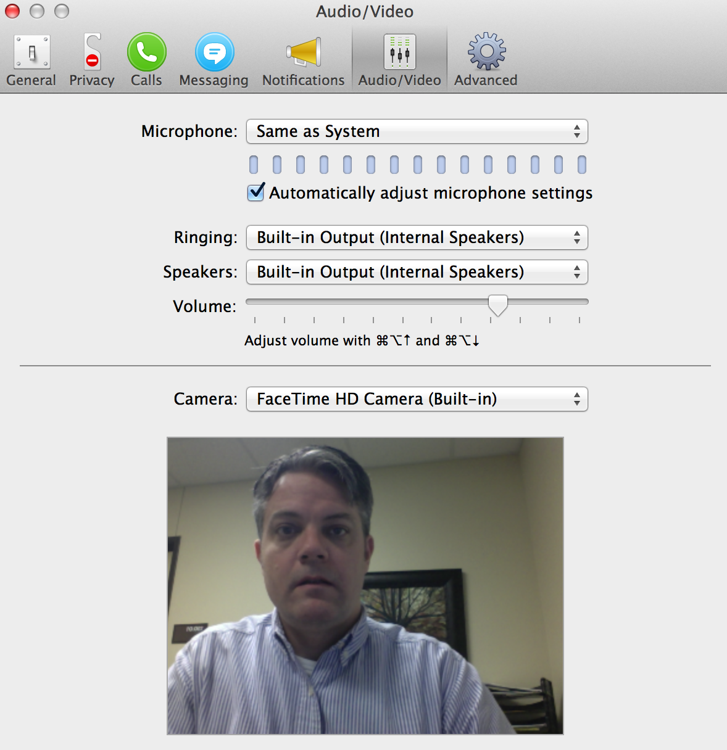
On a PC:
At the top of the Skype pop-up window, click on Tools and then on Options in the drop-down window.
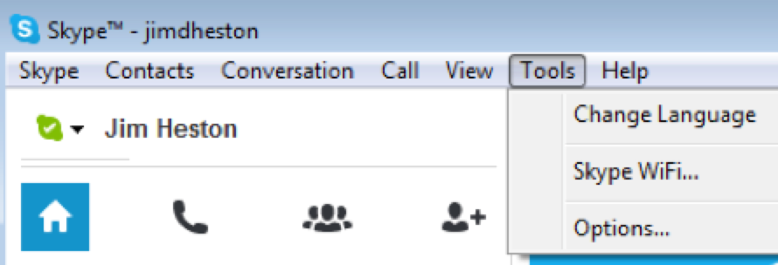
Then select Audio, sound, or Video settings on the left menu to test or select.
